IT24102390

PS Lab sheet 07

Question 1

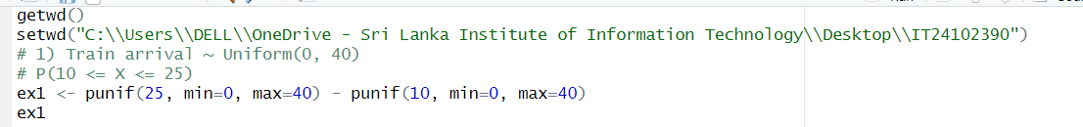

Question 2

Question 3

